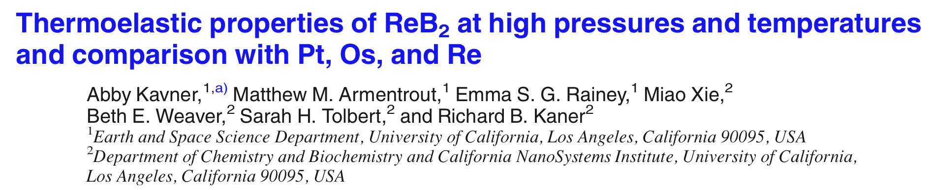
The goal of this study was to extend the pressure and temperature conditions of the measured structural stability and thermoelastic properties of ultrahard ReB₂. This data is important for understanding the basic physics of this class of materials and for guiding the design of new materials.
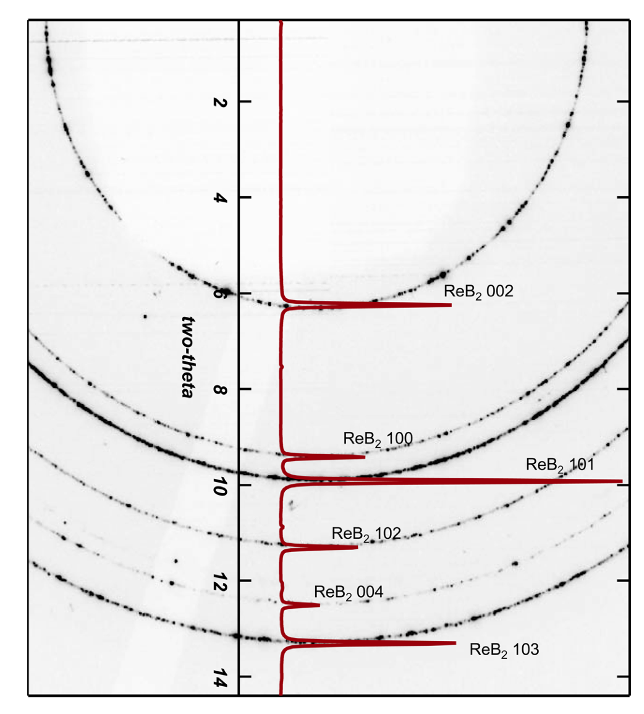
We have measured the phase stability and thermoelastic equation of state of ultrahard rhenium diboride at pressures up to 30 GPa and temperatures up to 2500 K using a laser heated diamond anvil cell in conjunction with synchrotron X-ray diffraction. The experimental work was performed during our CDAC beamtime at HPCAT. ReB₂ is shown to be stable throughout this pressure and temperature region. We show that ReB₂ has a small thermal anisotropy, but a large mechanical anisotropy. Combining this new data set with previously existing results from a large volume press yields a thermoelastic equation of state with a Grüneisen parameter of 2.4 (0.08) and a q of 2.7.
Left: X-Ray diffraction pattern of ReB₂ at 29 GPa and 2200 K. The red diffraction pattern with labeled peaks is the integration of the 2-di image.
A comparison of ReB₂ with other high electron density incompressible elemental metals shows that ReB₂ has the lowest thermal pressure at moderate compressions (below left) and a low thermal expansivity combined with high bulk modulus through a broad range of pressures (below right).
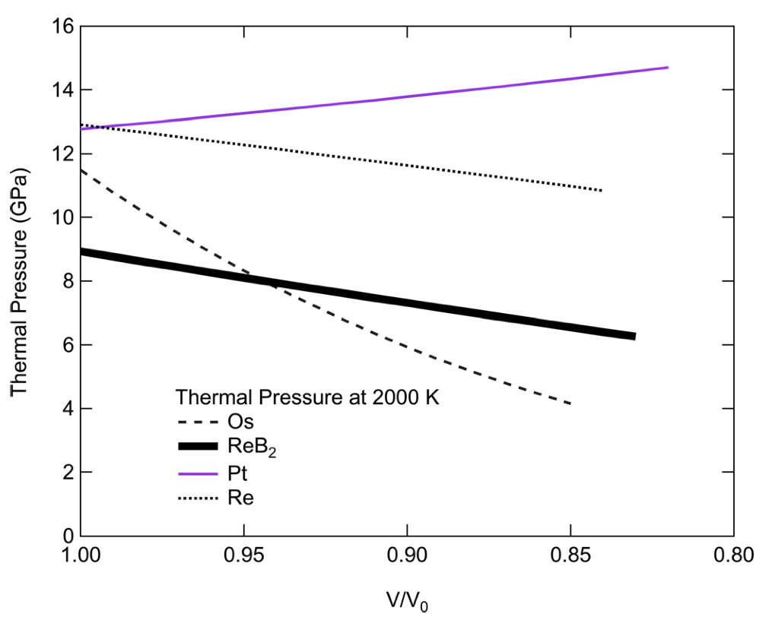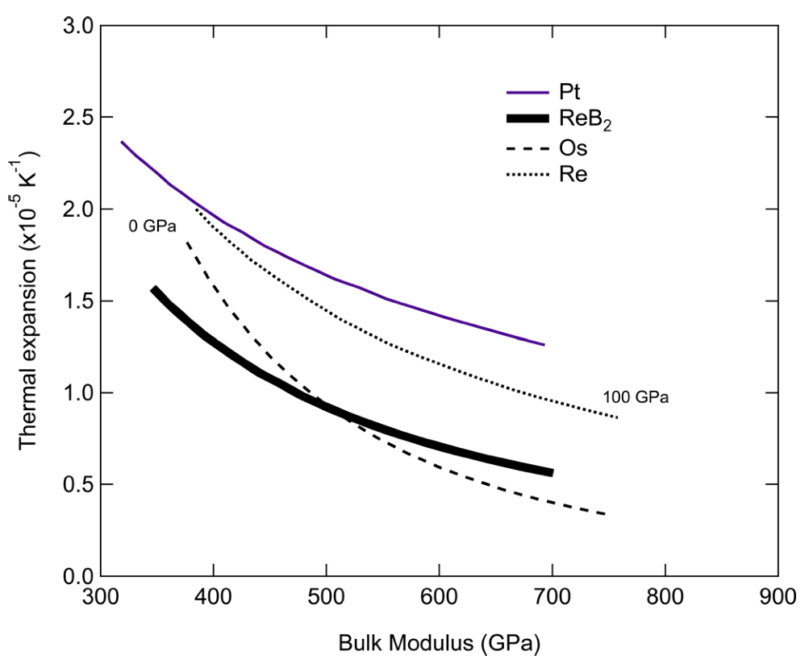
Above left: Thermal pressure of ReB2 as a function of compression (bold black line) compared with thermal pressure based on published equations of state for Os,Pt, and Re. Above right: A mechanical-design chart plotting the thermal expansion as a function of bulk modulus at 2000 K for ReB₂ and friends.

