ESS C109/C209 Isotope Geochemistry HW4
Due May 16, 2007

Part 1: Isotope dilution.

- Mass spectrometers are very good at measuring the isotopic composition of one element in a sample. However, it is often also necessary to determine the concentration of an element or isotope, and compare it to the abundance of an isotope of a different element (as in isochron and U,Th/Pb dating). Isotope dilution is one method that enables absolute concentrations to be determined from an isotope ratio measurement. This technique is discussed in section 4.4e of Faure & Mensing.
Using eq. 4.38, determine the concentration of vanadium in a 10g sample of an iron meteorite. The spike in this case is 1 ml of a solution of pure (100%) ⁵⁰V, at a concentration of 5 x 10^{–5} g/l.
  - Qualitatively, how much vanadium would you expect to find in an iron meteorite?
  - What are the normal abundances of ⁵⁰V and ⁵¹V?
  - After adding the spike to the sample and dissolving the mixture, its ⁵⁰V/⁵¹V ratio is determined to be 0.021. What is the concentration of vanadium in the meteorite (in gV/gMeteorite)?
  - If the procedure used to purify the vanadium from the dissolved meteorite sample isn’t perfect (i.e., contaminants make it through), what atoms and/or molecules might form ions with mass/charge ratios of 50 or 51, perturbing the measured ratio? Can you think of a way to use the mass spectrometer to check for the presence of these contaminants?
  - Isotope dilution is almost always done with a spike that has a high concentration of what is normally a rare isotope. Looking at eq. 4.38, can you come up with a reason why?
Part 2: ⁴⁰Ar*/³⁹Ar* geochronology
- High-precision geochronology is widely used for tectonic reconstruction and determining the ages of important objects and events in the evolution of life. One major area of study is the fossil record of human ancestors and relatives. The Tabarin mandible (with two teeth), reported by Stephen Ward and Andrew Hill from the Lake Baringo area in Kenya, is an example of an early hominid fossil (pictures next page).
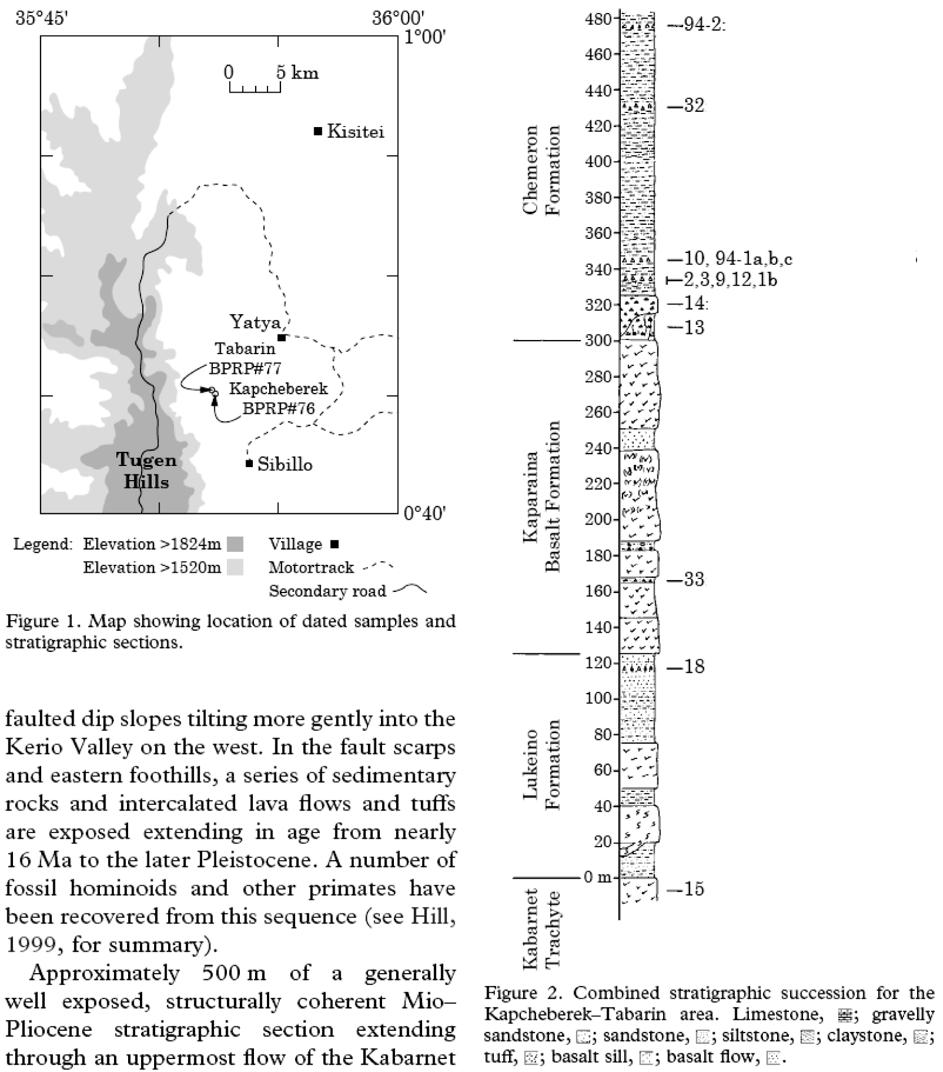
The sedimentary and volcanic rock section from which this fossil was recovered are shown on the previous page. Because of the importance of this fossil and others found nearby, this section has been carefully studied to determine how long ago it was deposited. The mandible fragment, in particular, was found approximately 1 meter above a tuff (volcanic) layer, corresponding to samples 10, and 94-1(a), (b), and (c) on the section. It is about 80 m below the next datable tuff, indicated as Sample 32. For each of these samples, a number of anorthoclase (KAlSi₃O₈) crystals were picked for ⁴⁰Ar*/³⁹Ar measurements. The data are shown below (from data of Deino and coauthors):
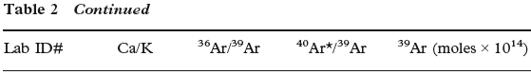

- Using eq. 7.8 from Faure and Mensing, determine the ages of each anorthoclase for these three samples. The values of the J-function (J) is 2.725x10⁻³ for samples beginning with "277", for "269" samples the J is 2.724x10⁻³, for "454", J = 2.933x10⁻³, for "1422", J = 1.361x10⁻³, and for "20075", J=1.709x10⁻³.
- Are there any outliers? By this I mean crystals that have a very different age from the other crystals in the sample. What might cause these crystals to be mixed in with material of a different age?
- Excluding outliers, what is the average age of the samples that come from 1 m below the fossil?
- What is the average age of the sample that comes from 80 m above the fossil?
- What is the age of the Tabarin mandible? Consider the maximum and minimum possible ages, and a “best estimate” age.
Part 3: U,Th/Pb geochronology
U,Th/Pb-zircon geochronolgy is the gold standard for geochronology for a number of reasons, including the toughness and durability of zircon, the accuracy of known decay constants, and the ability to correct age determinations in some crystals with open-system (parent or daughter loss/gain) histories. These properties are particularly important when dealing with the most ancient Earth samples, which have often experienced complicated and intense periods of metamorphism (heating & burial) after crystallization.
A famous exposure of very old rocks is in the southwest corner of Greenland, including the Isua Supercrustal belt and nearby Akilia. Data from Manning et al. (2006). Here we’re ignoring some of the geological context for simplicity.
- a) Using the data provided below (and assuming negligible initial concentration of daughter Pb isotopes), determine the ²³⁸U/²⁰⁶Pb. ²³⁵U/²⁰⁷Pb, and ²³²Th/²⁰⁸Pb ages of each sample of zircon from Akilia (²⁰⁷Pb/²⁰⁶Pb ages are already in the table).
b) Are the U/Pb, Pb/Pb, and Th/Pb ages the same for each sample? Which is typically the oldest? Why?
b) Plot the results on a Wetherill Concordia diagram. You may want to zoom in on the part that extends from ~3x10⁹ to 4x10⁹ years
c) Did these zircons experience significant lead loss?
d) How old are the Akilia rocks?

